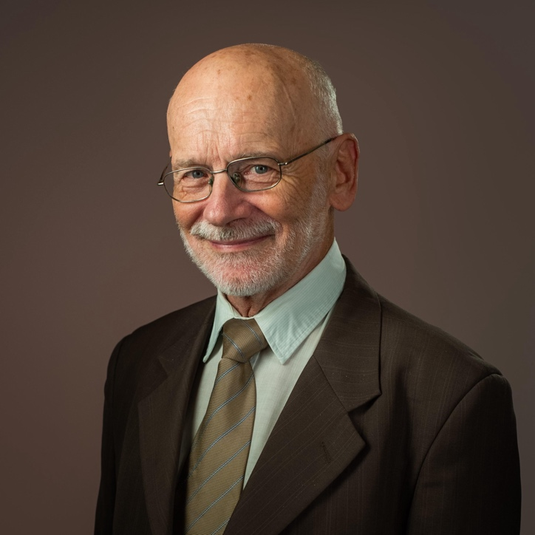

Marek Dabrowski is a Non-resident Fellow at Bruegel. He specialises in monetary and fiscal policies, trade policy and the political economy of policy reforms.
He covers country-specific and cross-country comparative analyses related to monetary and fiscal policy, macroeconomic trends, financial stability including financial crises, the global economy and financial architecture, the European Union and euro-area economy, European integration, and economic reforms in emerging-market economies, especially in central and eastern Europe, the former Soviet Union, and the Middle East and North Africa.
He speaks English, Polish and Russian.
He is also a co-founder and Fellow at the Centre for Social and Economic Research (CASE). Previously, he was a Visiting Professor at the Central European University in Vienna, Professor at the Higher School of Economics in Moscow and Fellow under the 2014-2015 Fellowship Initiative of the European Commission – Directorate General for Economic and Financial Affairs. Prior to this, he was a member of the Board of Trustees and Scientific Council of the E.T. Gaidar Institute for Economic Policy. He holds a PhD in Economics from the Institute of Planning, Warsaw.

